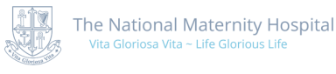 |  |  | FREEDOM OF INFORMATION REQUEST FORM
CONFIDENTIALITY AND DATA USE
The National Maternity Hospital fully respects your right to privacy and confidentiality in relation to your interaction with us through this anonymous Patient Experience Survey. All data and information that you volunteer will be treated with the highest standard of security and confidentiality, strictly in accordance with the Data Protection Act, 2018 and used only for the intended purpose of seeking to continually improve the quality and safety of our services.
PLEASE COMPLETE THE FORM BELOW AND SEND TO:.
Alan McNamara, FOI Officer, National Maternity Hospital, Holles St., Dublin D02 YH21
SURNAME:
(when patient of NMH)
FORENAME:
(when patient of NMH)
CURRENT SURNAME:
(if different to present)
HOME ADDRESS:
(when patient of NMH)
CURRENT HOME ADDRESS:
(if different to present)
 | DATE OF BIRTH:
HOSPITAL NUMBER:
(if known)
 | HOME TELEPHONE No.: |  |  | MOBILE No.:
 | DETAILS OF INFORMATION REQUEST:
 | SIGNED: |  |  |  | DATE:

